Gain = 2.775

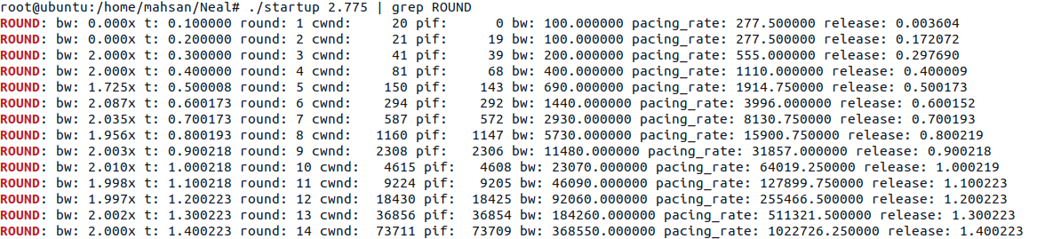

Gain=2.774

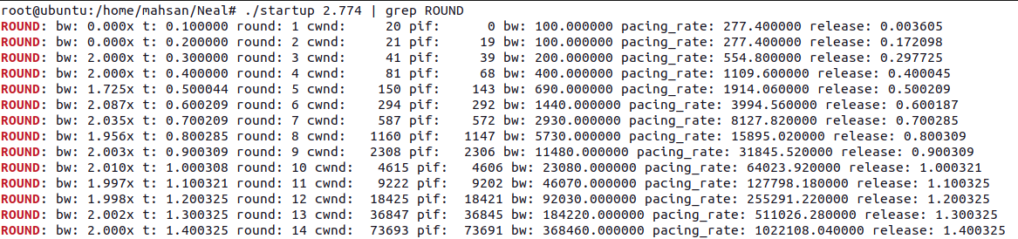

Gain=2.773

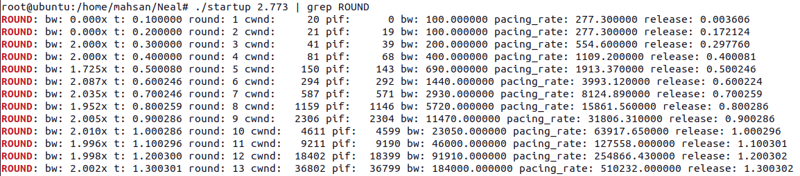

Gain=2.773 till round 15.

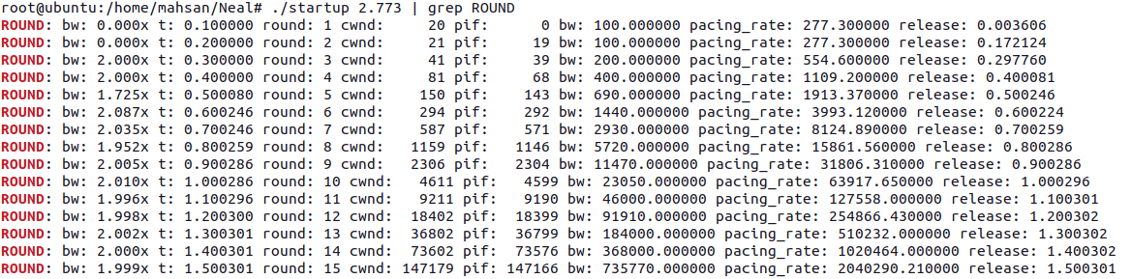

Now Gain=2.8

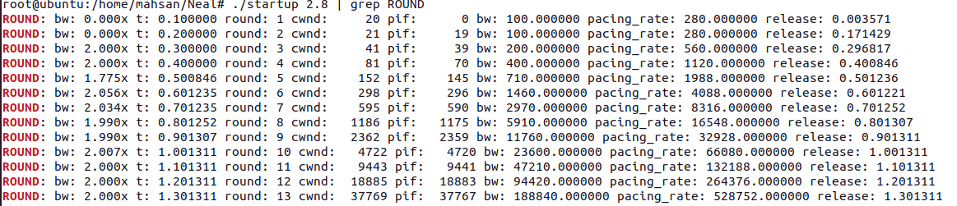

Gain:2.88

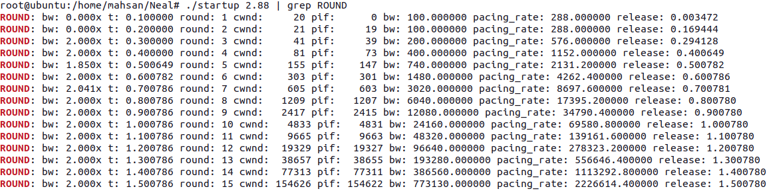

**Gain:2.885**

